Will we have no Charging Station in the Future?

Contact us:

ibsghk@gmail.com

—— Battery Swapping Station and its Prospect

Abstract:

* Battery swapping is obviously an essential part of the new energy vehicle industry chain. But in addition to the industry reason, we also need to consider the political reason when measuring the value of Battery swapping
* When focusing on the business model of battery swapping stations, it is evident that multi-brand servers and uni-brand servers have different business models, which we have also stated separately in this report
* The cost-benefit analysis was completed based on the fixed cost, operation cost, and potential profit of a battery swapping station
* Synthesizing the entire report, we give some thoughts on the future of battery swapping

**Content:**

Abstract: 1

1. Why should you look into this sector 3

1.1 Industry factor 3

1.2.Political reason 3

2. Market overview and business model 5

2.1. Multi-brand servers 5

2.2. Uni-brand servers 5

3. Cost analysis 6

3.1 Fixed cost 6

3.2 Operation cost 6

4. Profit analysis 7

4.1 Business model introduction 7

4.2 Battery swapping profit analysis 8

5. Cost-benefit analysis 11

6. Future prospect 12

1. **Why should you look into this sector?**

## Industry factors

The NEV sector has been booming in recent years, and battery service is the most important service after buying a car. However, the battery service is more than downstream of the NEV due to NEV’s nature as a platform and acts as an integrated part of the ecosystem. More and more manufacturers consider the NEV less like a car but more like a service and a platform, and comes MaaS (i.e., Mobile as a Service). In a nutshell, the relationship between NEV manufacturers and electricity providers is different from fuel vehicle manufacturers and gas stations. Most companies set up charging stations running by themselves, and there are also some individual providers.

How to provide car owners pleasant battery service draws the attention of companies and investors. Up to now, the main mode is the charging station, and the battery-swap station is the challenger. GCL Energy Technology has a recent refinance, and the raised capital is mainly invested in setting up battery-swap stations.

## Political Reason

It is generally accepted by Chinese investors that the reason why the government is keen on promoting NEV is more than environmental. About 1/3 of the petrol was consumed by fuel vehicles in 2021, and transferring to NEV is a key step for China to break away from the petrodollar system, given the current international pattern. The logic is shown below on the graph.

Techniques to advance the range and charging time can break the transformation barrier to NEV, which generates a premium on its value.

If you are interested in another key issue of transformation – Battery Recycling and Environmental Protection, you may refer to our past article Booming Industry Accelerated by ESG.

**2.Market overview and business model**

Battery swapping in China is an emerging sector driven by the regulatory benefits of battery-swapping station construction and the sweeping penetration of EVs in the region. Its market size is projected to grow at a CAGR of 27.1% globally for the next six years. Players in this sector can be dichotomized into multi-brand servers and uni-brand servers.

## Multi-brand servers

Multi-brand servers proffer battery swap services to multiple brands and often engage in the process of battery swap model design with their clients. Aulton New Energy Automotive Technology is a typical firm in this category, providing battery swapping services for bespoke models from top-tier OEMs. Standardization is a significant challenge for scaling up. Take Aulton as an example; it usually takes 6 to 12 months for Aulton to co-create a tailored battery swap model with its clients. In the current market, where neither battery swapping nor charging determines the energy reimbursement of the EVs, the lengthy design time is a massive impediment for these players.

The major customers of these servers are commercial vehicles. Commercial vehicles require a timely supplement of energy to run continuously since “time is money.” The Battery swapping station meets their demands by significantly compressing the time of energy reimbursement compared to the direct charger. Additionally, there are limited models for commercial vehicles, and the commercial operators often have control over their models, thus alleviating the standardization challenge for multi-brand servers.

## Uni-brand servers

Uni-brand servers usually are car brands themselves. NIO is the leading player in this category, providing battery swapping services to its customers. It has complete control over the design of the battery swapping model and station. The leading goat stages battery swapping as an additional value proposition for its post-sales services. As such, the profitability of this category of servers is questionable due to the growth driver being ceiled by the growth of the sale of its models.

**3.Cost Analysis**

## Fixed cost

1) Battery swapping equipment:

The swapping station is equipped with 30 batteries and requires four 630 transformer boxes. The cost of each 630-transformer box is about 0.25 million, and eight 630 transformer boxes are 1 million yuan. The technical content of the container battery-swapping station is small; generally, adopting the mode of external procurement, the total cost of a workshop for a battery-swapping station is around 0.1 million. Charging cabinet equipped with 30, the average price of 6000-7000 yuan, a total of about 0.2 million yuan. Another 0.1 million is needed for a weightlifting machine. The total equipment related to battery-swapping is about 1.5 million, with a depreciable life of 10 years.

2) Grid pulling cost:

Grid pulling cost occupies more than 20%-25 of the total cost, here based on 1 million yuan per station and a depreciation life of 10 years.

## Operation cost:

1) Site cost:

The site rent will fluctuate up and down with the change of footing. Since the battery-swapping station is a vacant building, the cost will be slightly lower than retail stores, and the average site rent is recorded as 0.1 million RMB/year.

2) Battery cost:

The average battery price is about 50 thousand yuan (60,000 for the high-end model, 50,000 for the mid-range, and 40,000 for the low-end model). The initial cost for 30 batteries is 1.35 million. Considering that the circulation of each battery is 2000 times on average (the average of LFP and ternary battery), so the annual cost of the battery is the service times per year divided by the circulation multiplied by the average battery price, which is about 0.38 million per year.

3) Electricity cost：

The cost of electricity for charging depends on the specific situation in each province and city and is estimated here at 0.7 RMB/kWh

4) Labor and other costs:

Most of the battery-swapping stations are still not automated, and generally, two people are on duty. For a 24-hour station, a total of 4 employees are needed, each working 56 hours per week, for a total labor cost of about 0.4 million per year. Some maintenance costs are also associated with the plant, which is 0.15 million per year.图表, 饼图

**4. Profit Analysis**

## 1. Business model introduction

The midstream of the electric vehicle battery swapping industry chain is mainly composed of battery swapping operators and battery banks. The battery swapping operator is responsible for the daily operation and maintenance of the battery swapping station. Among the mainstream operators, the NIO battery-swapping station is built for its own cars. While Aulton cooperates with BAIC, SAIC, and other old car enterprises, providing battery swapping services for their cars.

In addition to battery swapping operators, a battery bank is also an important midstream process in the battery swapping industry chain. Consumers can choose to buy electric vehicles without power batteries and rent power batteries from battery banks. The battery bank purchases power batteries, obtaining benefits through the battery rental fees delivered by consumers and the full life cycle management of batteries to recover its cost and forming a closed-loop business model for battery swapping. The operation and management of a battery bank involve battery purchase and rental, battery operation, energy storage vehicle network interaction, echelon utilization, disassembly and recycling, and other services.

Because the business models of the two parts of the midstream are quite different, their profits should be analyzed separately.

## 2. Battery swapping profit analysis

In terms of profits, the two major operators, NIO and Aulton, have adopted different business models. NIO regards the battery swapping service as the value-added service of NIO automobiles. NIO consumers who pay the deposit on or before October 11, 2020, can enjoy unlimited battery swapping services for their whole life. Consumers who pay the deposit on or after October 12, 2020, will have the right to free battery swapping service 4 times a month if they choose to install free home charging points and 6 times a month if they choose not to install free home charging points.

According to the big data report issued by Tencent location service, the average travel radius of office workers in Beijing is 9.3 kilometers on weekdays, with a daily commute distance of 20 kilometers. Considering that the mileage of the NIO car is about 600km to 1000km, even the free battery swapping times given to new users can fully cover their daily use. Therefore, when we calculate NIO's profit, we should consider the sales growth brought by the free battery swapping service instead of the service fee. According to research on Transportation Research Record, free charging police will increase by around 60% EV sales.

Presently, Aulton mainly serves operating vehicles, such as taxis, and will also consider the layout of private cars in the future. Therefore, when calculating the profit of Aulton, we only need to consider the daily service times and the average single-time income of the battery swapping station. The Aulton battery-swapping station uses the method of charging by kilometer, with 0.3 yuan per kilometer. The charging amount can be calculated through an odometer. We assume that taxis generally enter the battery-swapping station when the remaining power is 20%. Taking BAIC new energy eu220 as the target model, the mileage of BAIC new energy eu220 is 300 kilometers, and the fee for each battery swapping is about 72 yuan. Taking Aulton battery-swapping station 3.0 as an example, it can provide 240 times service at full load 24 hours a day, and the utilization rate is calculated at 20%. Then we can get that the annual income of one battery-swapping station is about 2.21 million yuan.

Since the business model of Aulton and NIO is quite different, and they are targeting different client groups, it is hard to say which one is better. NIO and Aulton are pioneers in their own way and try hard to prove that their business model is practical and profitable.

For battery banks, the profits they can obtain in the whole life cycle of batteries are also divided into two parts. One part is the rental income brought by battery leasing, and the other is the recovery income obtained from recycling the scrapped battery.

The service life of a power battery is usually 4-6 years. After that, it is difficult for power batteries to support the use of electric vehicles. Five years is adopted here as the standard. Taking the baas service price provided by NIO as an example, the profit of the whole life cycle of a 75kwh battery is 58800 yuan, while the profit of a 100kwh battery is 88800 yuan.

Regarding battery recycling, there are mainly two kinds of power batteries on the market: ternary battery and lithium iron phosphate battery. The profit of disassembling lithium iron phosphate batteries is low, so it is generally recycled in the way of echelon utilization. However, due to too many links involved in echelon utilization, and the current market still lacks a perfect echelon utilization mechanism and supporting facilities, the profit of echelon utilization is difficult to calculate. For ternary batteries, if the mainstream wet recycling in the market is adopted, the net profit recovered per ton of ternary batteries is 3015 yuan, according to lithium-ion battery recycling and recycling technology.

Then comes its competitor’s charging point. The charging standard of the charging point also includes two parts: electricity fee and service fee. Electricity fees change over time. Taking the State Grid as an example, the total cost from 10:00 to 21:00 is about 1.7 yuan/degree, while the total cost from 21:00 to 10:00 is between 1.1 yuan/degree and 1.4 yuan/degree. If the user charges at his own charging point, a service fee of 0.3 yuan / kWh will be added to the basic electricity charge of about 0.5 yuan / kWh. The installation cost of a charging point is different for the different enterprises. The cost of State Grid is 2000 yuan, NIO is 7000 yuan, and Tesla is 8000 yuan.

**5. Cost-benefit Analysis**

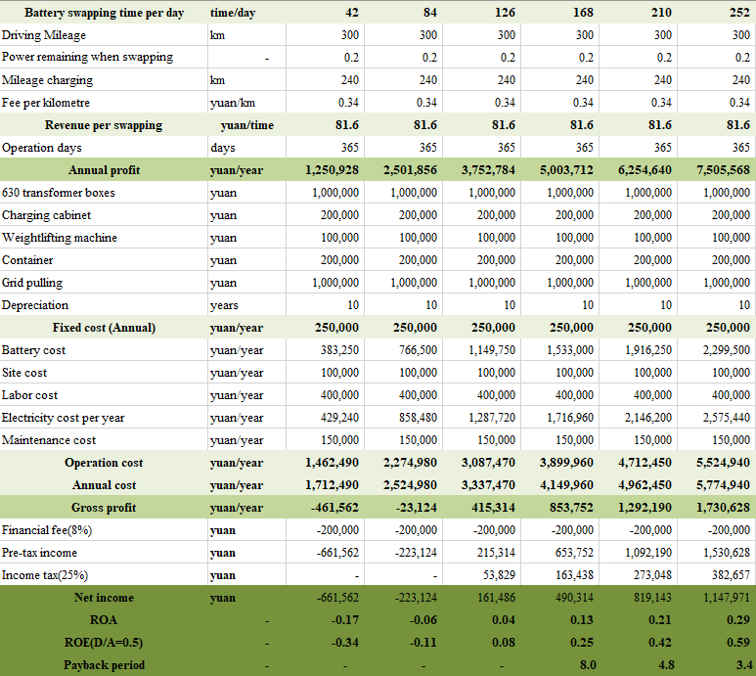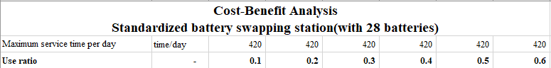

# 6. Future Prospect

If we assume that even though the speed of charging points increases a lot, it is still slower than battery-swapping stations, in the future, the application scenarios of Battery Swapping stations and Charging points should be distinctive according to their own typical features.

Battery Swapping stations will take the place of petrol stations as there won’t be any petrol cars in the future. Benefiting from its high speed, it only takes passengers several minutes to fully charge their cars. The application scenario of battery swapping is outdoor and mainly for emergencies and commercial vehicles.

For Charging points, the most widely adopted form of them is being installed on pillars in the parking lot as they won’t take up too much space in this form. People use charging points when arriving home or in their company. The application scenario of charging points is indoor and mainly for private cars. Besides, battery swapping will be their daily charging form for those who don’t have their own parking spots.